Pure components
- Pure components are used to prevent unnecessary re-rendering of child component when parent components renders.
- It helps to improve the performance of components.
- Pure components are present in Class Based Componenets.
- Pure components extends its properties from PureComponent
App.jsx
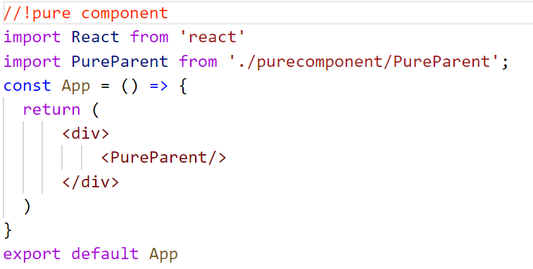
PureParent.jsx
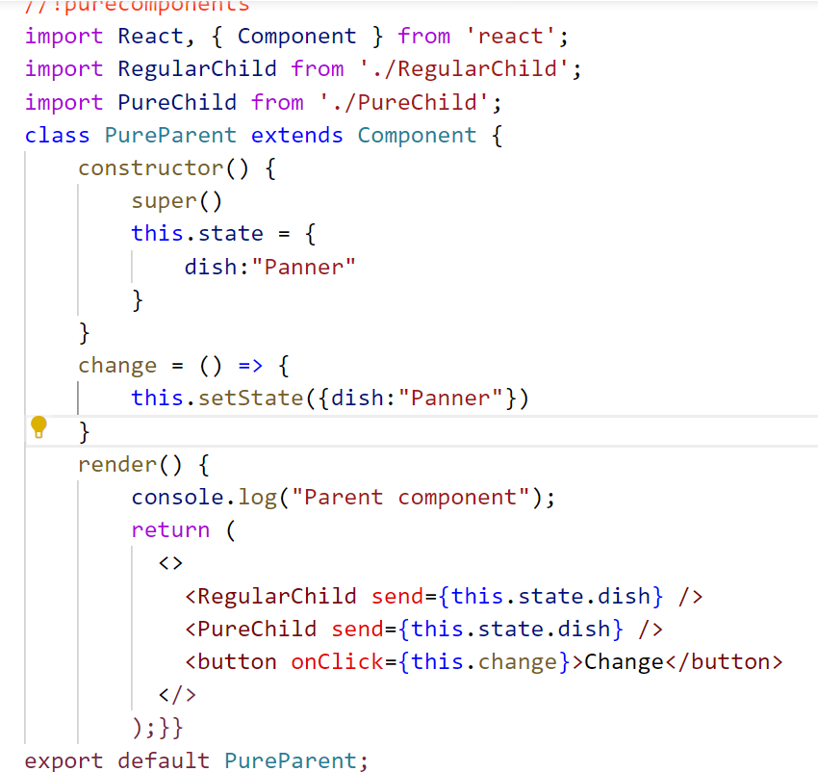
RegularChild.jsx
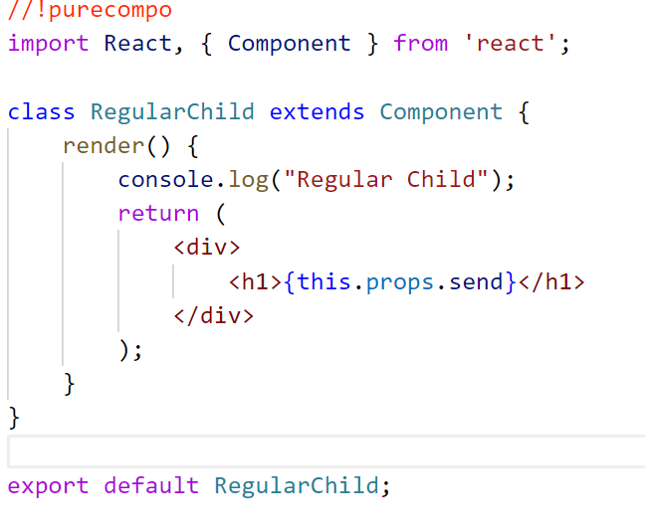
PureChild.jsx
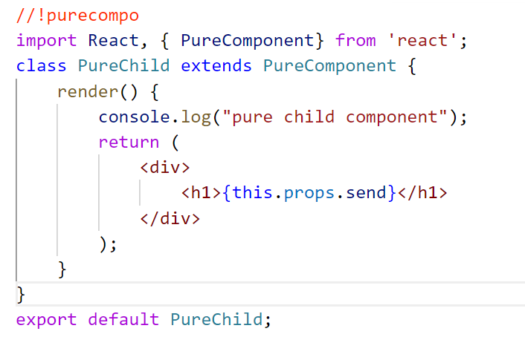
React Memo
- Memo will memorize the entire component due to which if a state having non-primitive data is not changing actually then component will not re-render.
- Memo used to skip the re-rendering of child components when the parent components renders in FBC.
- The component which you don’t want re-render simply wrap those componets with React.memo
- Memo is one Higher Order Component.

App.jsx
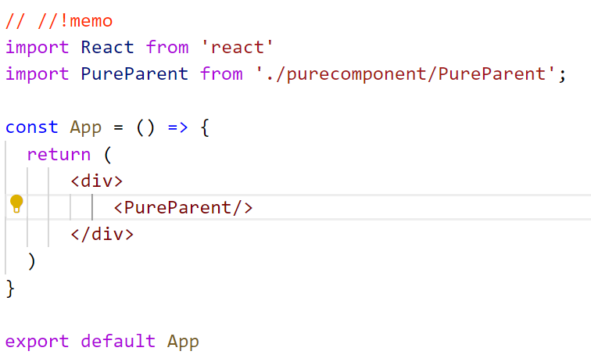
PureParent.jsx
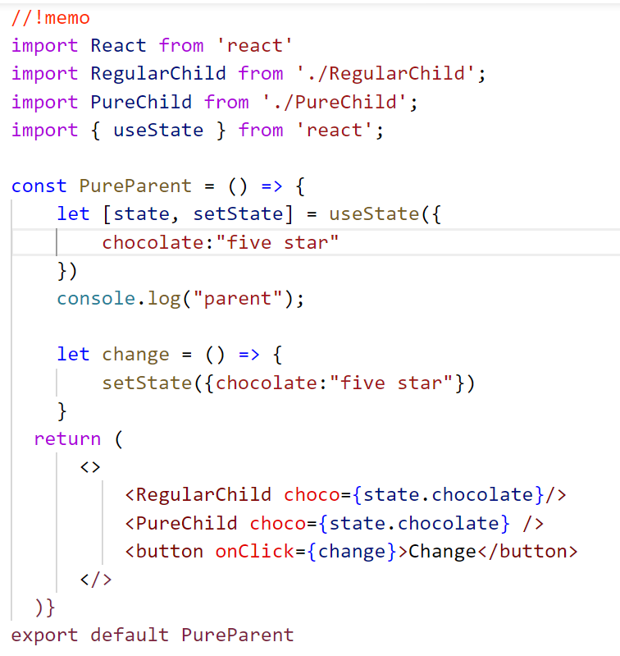
RegularChild.jsx
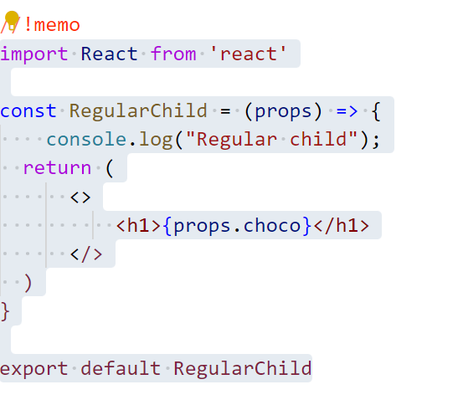
PureChild.jsx
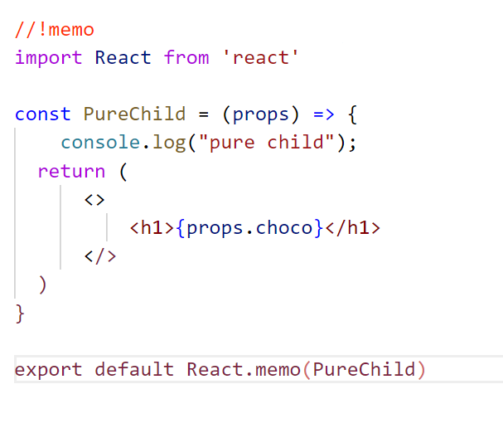
useMemo( ) :
- useMemo it is a hook.
- It will memorized a particular values in an outcome of a function or results of a function.So that other functions will not be effected.
- useMemo( ) accepts 2 values
- A function that performs the expensive computation.
- An array of dependencies. The memoized value will only be recalculated if any of the dependencies have changed.
App.jsx
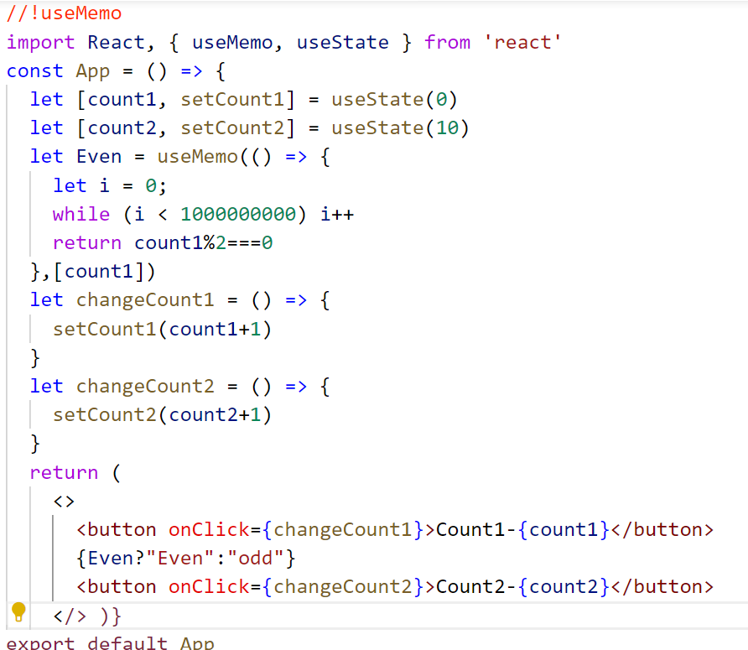
- In the above example heavy function is applicable only for state count1. So we wrapped that function with useMemo( ) so it will memorized the value of that particular function.
- Here we have to pass the dependency to indicate that it should be applicable for only count1 state variable

useCallback( )
- useCallback( ) it is a hook.
- It will memorized the entire function instead of the value returned by the function.

App.jsx
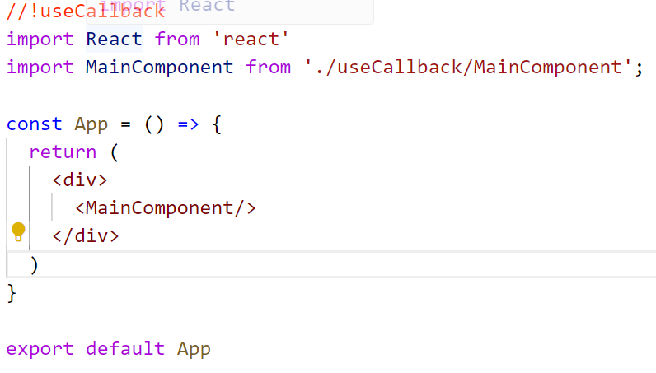
MainComponent.jsx
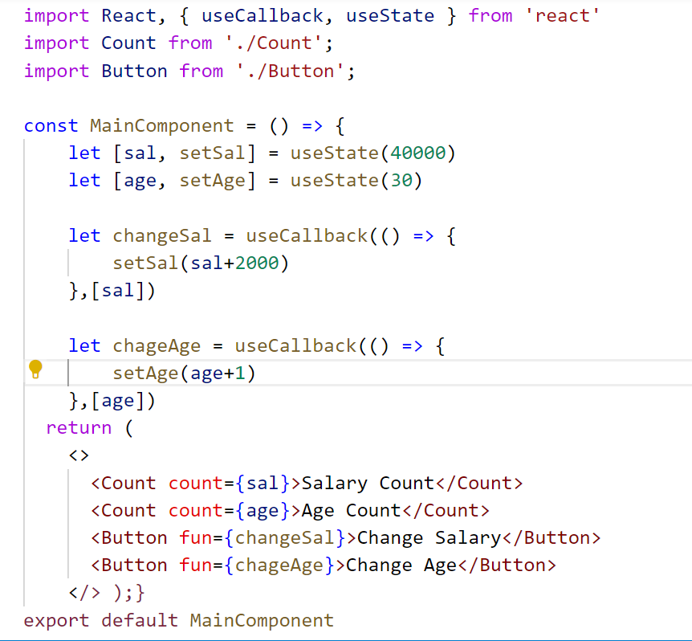
Here the functions are wrapped by useCallback() separately and we passed the dependency list. To indicate that only if for the particular state value functions should execute.

Count.jsx
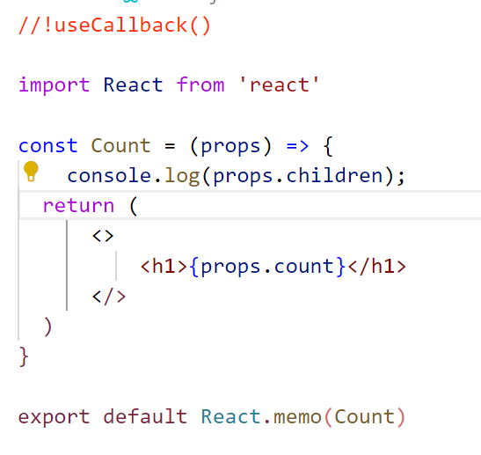
Button.jsx
